Article
English TItle

Gildong Hong¹ Cheolsu Kim² Younghee Kim³
¹Gildong University ²Cheolsu University ³Younghee University
Abstract
The purpose of this study was... (Please write your abstract in 250-300 words)

Keywords: Keyword 1, Keyword 2, Keyword 3, Keyword 4, Keyword 5
History of this Article: Received (24.06.01), Revised (24.07.01 / 24.08.01), Accepted (24.09.01)
Funding Information: This study is...
Correspondence Authors’ Email: abcdefg@hijklm.com

Ⅰ Introduction
(1 line space between chapter title and body)
Research papers submitted to this journal include creative and original experimental research, theoretical research, survey research, case studies, and case studies conducted by the contributors. Submitting a research paper should include proof that the material presented is objective (Hong, 2020).
(2 line space between chapters)

Ⅱ Theoretical Background

Research papers can be written in either Korean or English, but Korean manuscripts should be in Korean files, and English manuscripts can be in MS Word (Linda & Cindy, 2024).
(Single space before the middle title)
- Topic
For the title of the paper (Linda et al., 2023), write the title in both Korean and English; if the paper is in Korea, write the Korean first and the English second. For English papers, the title of the research paper should be written in English only.
(Single space before and after the table)
Table 1. Title of the Table
Topic1 | Topic2 |  | Topic3
1 |  | A | Content
2 |  | B | Content
(Single space before and after the table)
Reference should be organized according to the following rules.
(Single space before subheadings)
1) Subheadings 1
References should be written in both Korean and English according to APA style (Michael, 2018). For Korean references, use the following format: according to Hong and Kim (2020) – 2 authors / Hong et al. (2020) – 3 or more authors. For English, Linda (2006) – 1 author / Linda and Cindy (2001) – 2 authors / Linda et al. (2003) – 3 or more authors.

2) Subheadings 1
① Subheadings 2
The font for the body should be ‘Times New Roman’. The text size of the body should be 9 points.
(Single space before and after the Figure)
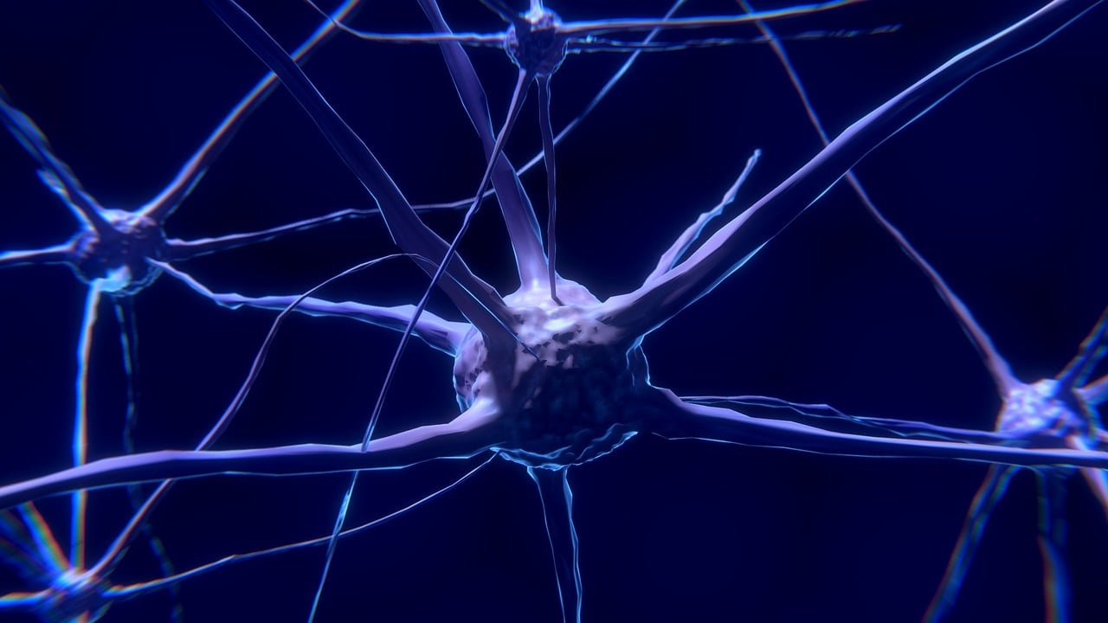
Figure 1. Nerve Cell
(Single space before and after the Figure)
References

Cindy, A. (2000). TItle of Book Chapter. In P. M. Linda, B. C. Michael (eds), Title of the Book (pp.000-000), Publisher.
Linda, P. M., Cindy, A., & Michael, B. C. (2023). Title of Article. Title of Journal, 1(1), 000-000.
Linda, P. M., Cindy, A. (2024). Title of Article. Title of Journal, 1(1), 000-000.
Michael, B. C. (2018). Title of the Book. Publisher.

Research Ethics

IRB information / Information to understand ethics compliance

Author Information
Name | Affiliation |  | Position

